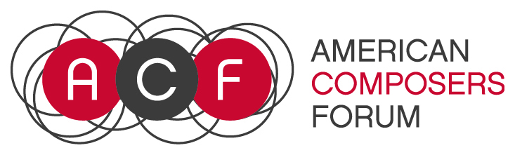
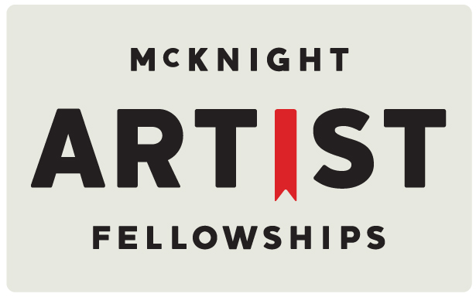

The American Composers Forum encourages applicants from the full range of musical styles, and is committed to supporting a diverse pool of artists whose work demonstrates strong artistic merit. Accordingly, awards for our programs will represent, as far as possible, artists and projects that are diverse in genre, gender, race, ethnicity and geography.

2018 McKnight Composer Fellowship Worksheet
This worksheet is being provided so that you can start work on your application prior to the opening of the online application process.

- I have read the guidelines for the 2018 McKnight Fellowship for Composer Program?

- Last Name:

- First Name:

- Middle Name:

- Street Address Line 1:

- Street Address 2:

- City:

- State:

- ZIP Code:

- Phone Number:

- Email Address:

- Your Website URL:

- Artist Statement (3,500 Character limit including spaces)
The artist statement may take any of several directions, at your discretion: information about your background, the development of your work, your interests as an artist or your aesthetic position, your future artistic direction, or any other information you would like to present to the panel.

- Insights into your artistic experiences (Question 14: Two-pages maximum – PDF only – up to 10MB) This can be a biography, a list of 10 artistic experiences that have shaped you as a musician, or a resume. We would like this document to enhance your artistic statement and provide further insights into your creation of music. If you chose to list a set of 10 artistic experiences, please go deeper into details on two of the most important experiences out of the ten experiences.

- Complete works list (PDF only – up to 10 MB)
Include Title, Year Completed, Duration, Instrumentation, date of premiere, and performer or ensemble that premiered the work.

- Work Sample 1 – PDF up to 10 MB (Score, Chart, or Description)
Written scores are required unless they are inappropriate to your compositional style. For an improvised performance, please clearly describe the nature of your involvement as the composer in the creation of the piece in a document uploaded of hosted in the link provided.

- Work Sample 1 – Web link to score only if PDF is larger than 10 MB

- Work Sample 1 – Web Link to Audio
All web links provided must remain active and unchanged until June 2018.

- Work Sample 1 – Cue Start Time (if needed)

- Work Sample 1 – Title

- Work Sample 1 – Total Duration

- Work Sample 1 – Year of Completion

- Work Sample 1 – Ensemble or Name(s) of Performer(s)

- Work Sample 1 – Brief Description of Work (3000 Character Limit including spaces) You may also provide other pertinent information you feel would be of use to the panel, such as how it fits into your body of work and why you chose to submit this particular sample.

- Work Sample 2 – PDF up to 10 MB (Score, Chart, or Description)
Written scores are required unless they are inappropriate to your compositional style. For an improvised performance, please clearly describe the nature of your involvement as the composer in the creation of the piece in a document uploaded of hosted in the link provided.

- Work Sample 2 – Web link to score only if PDF is larger than 10 MB

- Work Sample 2 – Web Link to Audio

- Work Sample 2 – Cue Start Time (if needed)

- Work Sample 2 – Title

- Work Sample 2 – Total Duration

- Work Sample 2 – Year of Completion

- Work Sample 2 – Ensemble or Name(s) of Performer(s)

- Work Sample 2 – Brief Description of Work (3000 Character limit including spaces) You may also provide other pertinent information you feel would be of use to the panel, such as how it fits into your body of work and why you chose to submit this particular sample.

- Work Sample 3 – PDF up to 10 MB (Score, Chart, or Description)

- Work Sample 3 – Web link to score only if PDF is larger than 10 MB

- Work Sample 3 – Web Link to Audio

- Work Sample 3 – Cue Start Time (if needed)

- Work Sample 3 – Title

- Work Sample 3 – Total Duration

- Work Sample 3 – Year of Completion

- Work Sample 3 – Ensemble or Name(s) of Performer(s)

- Work Sample 3 – Brief Description of Work (3000 Character limit including spaces) You may also provide other pertinent information you feel would be of use to the panel, such as how it fits into your body of work and why you chose to submit this particular sample.

- By applying, you attest:
- to the accuracy of the information supplied in the application
- application materials submitted is the applicants sole and original work
- understand the purpose and conditions of the McKnight Composer Fellowship program and to your acceptance to them should you be selected as a fellow
- you are eligible for the competition, and that you will notify the American Composers Forum’s Vice President of Programs if you become ineligible prior to the conclusion of the competition.
- providing false or misleading information on this application, or failing in any other way to comply with the rules will subject you to disqualification and forfeiture of the fellowship.

Demographic form
- (Optional) Race/Ethnicity

- (Optional) I identify my gender as

