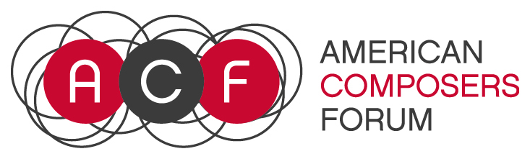

The American Composers Forum encourages applicants from the full range of musical styles, and is committed to supporting a diverse pool of artists whose work demonstrates strong artistic merit. Accordingly, awards for our programs will represent, as far as possible, artists and projects that are diverse in genre, gender, race, ethnicity and geography.

2018 McKnight Visiting Composer Worksheet
This worksheet is being provided so that you can work on your application outside of the online application process. Only applications submitted through the SlideRoom online application system will be accepted. The deadline for this program is Monday, Monday, March 12, 2018 11:59 PM CST.

- I have read the guidelines for the 2018 McKnight Fellowship for Composer Program?

- Last Name:

- First Name:

- Middle Name:

- Street Address Line 1:

- Street Address Line 2:

- City:

- State:

- ZIP Code:

- Phone Number:

- Email Address:

- Your Website URL:

- Project Proposal (6,000-character limit including spaces)
The project proposal should include a detailed description of your proposed residency activities while you are in Minnesota, including your interaction with the community you’ve chosen, and an explanation of the anticipated value of the residency for that community.

- Artist Statement (4,000-character limit including spaces)
A statement explaining the development of your work, your interests as an artist or your aesthetic position, why the residency you’ve designed would be valuable to you, and any other information you would like to present to the panel.

- Insights into your artistic experiences (4,000-character limit including spaces)
This can be a biography or a list of 10 artistic experiences that have shaped you as a musician. We would like this document to enhance your artistic statement and provide further insights into your creation of music. If you chose to list a set of 10 artistic experiences, please go deeper into details on two of the most important experiences out of the ten experiences.

- Support Materials (Web link to materials)
Other relevant support materials, such as letter(s) of commitment from individuals and organizations involved in your proposed project (optional, but preferred when the proposal requires the involvement of specialized communities).

- Work Sample 1 – Web link to Score

Written scores are required unless they are inappropriate to your compositional style. For an improvised performance, please clearly describe the nature of your involvement as the composer in the creation of the piece in a document uploaded of hosted in the link provided. All links provided must remain active and unchanged until June 2018.

- Work Sample 1 – Web Link to Audio or Video
All web links provided must remain active and unchanged until June 2018.

- Work Sample 1 – Cue Start Time (if needed)

- Work Sample 1 – Title

- Work Sample 1 – Total Duration

- Work Sample 1 – Year of Completion

- Work Sample 1 – Ensemble or Name(s) of Performer(s)

- Work Sample 1 – Brief Description of Work (3,000-character limit including spaces) You may also provide other pertinent information you feel would be of use to the panel, such as how it fits into your body of work and why you chose to submit this particular sample.

- Work Sample 2 – Web link to Score
Written scores are required unless they are inappropriate to your compositional style. For an improvised performance, please clearly describe the nature of your involvement as the composer in the creation of the piece in a document uploaded of hosted in the link provided. All links provided must remain active and unchanged until June 2018.

- Work Sample 2 – Web Link to Audio or Video

- Work Sample 2 – Cue Start Time (if needed)

- Work Sample 2 – Title

- Work Sample 2 – Total Duration

- Work Sample 2 – Year of Completion

- Work Sample 2 – Ensemble or Name(s) of Performer(s)

- Work Sample 2 – Brief Description of Work (3,000-character limit including spaces) You may also provide other pertinent information you feel would be of use to the panel, such as how it fits into your body of work and why you chose to submit this particular sample.

- Work Sample 3 – Web link to Score
Written scores are required unless they are inappropriate to your compositional style. For an improvised performance, please clearly describe the nature of your involvement as the composer in the creation of the piece in a document uploaded of hosted in the link provided. All links provided must remain active and unchanged until June 2018.

- Work Sample 3 – Web Link to Audio or Video

- Work Sample 3 – Cue Start Time (if needed)

- Work Sample 3 – Title

- Work Sample 3 – Total Duration

- Work Sample 3 – Year of Completion

- Work Sample 3 – Ensemble or Name(s) of Performer(s)

- Work Sample 3 – Brief Description of Work (3000-character limit including spaces) You may also provide other pertinent information you feel would be of use to the panel, such as how it fits into your body of work and why you chose to submit this particular sample.

- By applying, you attest:
- to the accuracy of the information supplied in the application
- application materials submitted is the applicants sole and original work
- understand the purpose and conditions of the McKnight Composer Fellowship program and to your acceptance to them should you be selected as a fellow
- you are eligible for the competition, and that you will notify the American Composers Forum’s Vice President of Programs if you become ineligible prior to the conclusion of the competition.
- providing false or misleading information on this application, or failing in any other way to comply with the rules will subject you to disqualification and forfeiture of the fellowship.

Demographic Information (Optional)
- I identify my race/ethnicity as

- I identify my gender as

