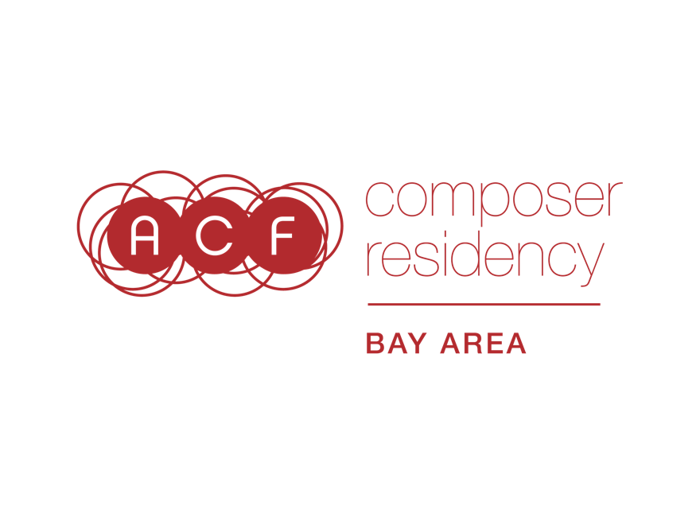

APPLICATION WORKSHEET
* = Required Question
1. *Last Name
2. *First Name
3. Middle Name
4. *Street Address Line 1
5. Street Address Line 2
6. *City
7. *Zip Code
8. *Bay Area county you reside in
(Alameda, Contra Costa, Marin, Monterey, Napa, San Francisco, San Mateo, Santa Clara, Santa Cruz, Solano, or Sonoma County)
9. *Phone Number
10. *Email Address
11. Your website URL (If you don't have a website, you can also put a Facebook Artist page, Soundcloud, or Bandcamp link here)
________________________
12. *Project proposal (Link to a 3-5 minute video or typed answer of maximum 6,000 characters, including spaces): Your project proposal should include a detailed description of your proposed residency activities, including your interaction with the project partner(s) you’ve chosen, and an explanation of the anticipated significance of the residency for your partner(s).

Written proposal (6,000 character typed limit including spaces)
OR
Link to my video proposal (3-5 minutes)

13. *Please share your intended timeline for the project you're proposing (typed answer, maximum 2000 characters, including spaces).
________________________

14. *Artist’s statement (Link to a 2-4 minute video or typed answer of maximum 4,000 characters, including spaces): Here is where you share why the residency you’ve designed would be significant for you; background on the development of your creative work; your interests as an artist, and any other information you would like to present to the panel.

Written artist statement (4,000 character typed limit including spaces)
OR
Link to my video artist statement (2-4 minutes)
________________________

15. *Insights into your artistic experiences (Link to a 2-4 minute video or typed answer of maximum 4,000 characters, including spaces): This can be a biography or a list of artistic experiences that have shaped you as a musician. We would like this document to enhance your artistic statement and provide further insights into your creation of music.

Written artistic experiences (4,000 character typed limit including spaces)
OR
Link to my artistic experiences video (2-4 minutes)
________________________

16. *Project partner(s). Type the name(s)/organization(s) you’ll be collaborating with. Project partner(s) are only allowed to collaborate with one composer applicant. Make sure your project partner has not also agreed to be a part of another composer’s ACF Bay Area application.

17. *Link to letter(s) of support from your project partner(s).
________________________

18. Work sample 1 - Link to score
Written scores are required unless they are inappropriate to your compositional style. For improvised performance, please clearly describe the nature of your involvement as the composer in the creation of the piece. All web links provided must remain active and unchanged until July 31, 2019.
19. *Work Sample 1 - Link to audio/video
20. Work Sample 1 - Cue time
Among the three work samples, the panel will listen to a maximum of 12 minutes. You can divide up these 12 minutes however you choose. Give a cue start/end time if you want the panel to review a specific section of this sample.
21. Work Sample 1 - Total Length
22. Work Sample 1 - Year Created
23. Work Sample 1 - Ensemble/performers' names
24. Work Sample 1 – Instrumentation
25. Work Sample 1 - Description (1,000 character limit including spaces)
Context about why you chose to share this particular sample, how it fits into your body of work, and/or your role in creating the music.
________________________

26. Work sample 2 - Link to score
Written scores are required unless they are inappropriate to your compositional style. For improvised performance, please clearly describe the nature of your involvement as the composer in the creation of the piece. All web links provided must remain active and unchanged until July 31, 2019.
27. *Work sample 2 - Link to audio/video
28. Work Sample 2 - Cue time
Among the three work samples, the panel will listen to a maximum of 12 minutes. You can divide up these 12 minutes however you choose. Give a cue start/end time if you want the panel to review a specific section of this sample.
29. Work Sample 2 - Total Length
30. Work Sample 2 - Year Created
31. Work Sample 2 - Ensemble/performers' names
32. Work Sample 2 – Instrumentation
33. Work Sample 2 - Description (1,000 character limit including spaces)
Context about why you chose to share this particular sample, how it fits into your body of work, and/or your role in creating the music.
________________________

34. Work sample 3 - Link to score
Written scores are required unless they are inappropriate to your compositional style. For improvised performance, please clearly describe the nature of your involvement as the composer in the creation of the piece. All web links provided must remain active and unchanged until July 31, 2019.
35. *Work sample 3 - Link to audio/video
36. Work Sample 3 - Cue time
Among the three work samples, the panel will listen to a maximum of 12 minutes. You can divide up these 12 minutes however you choose. Give a cue start/end time if you want the panel to review a specific section of this sample.
37. Work Sample 3 - Total Length
38. Work Sample 3 - Year Created
39. Work Sample 3 - Ensemble/performers' names
40. Work Sample 3 – Instrumentation
41. Work Sample 3 - Description (1,000 character limit including spaces)
Context about why you chose to share this particular sample, how it fits into your body of work, and/or your role in creating the music.
________________________

42. How did you find out about this opportunity?
ACF email
ACF social media
Center for New Music
Friend or family
Can't recall
Other
________________________

43. I identify my race/ethnicity as:

44. I identify my gender as:

Providing this information is optional. The American Composers Forum strives to include applicants from the full range of musical styles, and is committed to supporting a diverse pool of artists in genre, gender identity, race, ethnicity, and geography. Sharing your information helps us know how we are doing and where we might improve our efforts.

The deadline is 12:00pm Pacific Time on June 3, 2019. SlideRoom allows you to exit and re-enter your application up until the point you hit Submit. If you need technical help while working on your application, please contact Kris Kautzman at 651.251.2842 or kkautzman@composersforum.org.

